REPORT
EXPENSE TRACKER

- Goal
The expense API is aimed at helping individuals , track their daily and monthly expenditure. Sometimes people end up spending a lot more than they would love to because they do not have a track record of their total expenditure. This limits on their level of savings or they end up even not saving a tall which not a good culture. This API will help some keep a track record of their expenses .
- Architecture
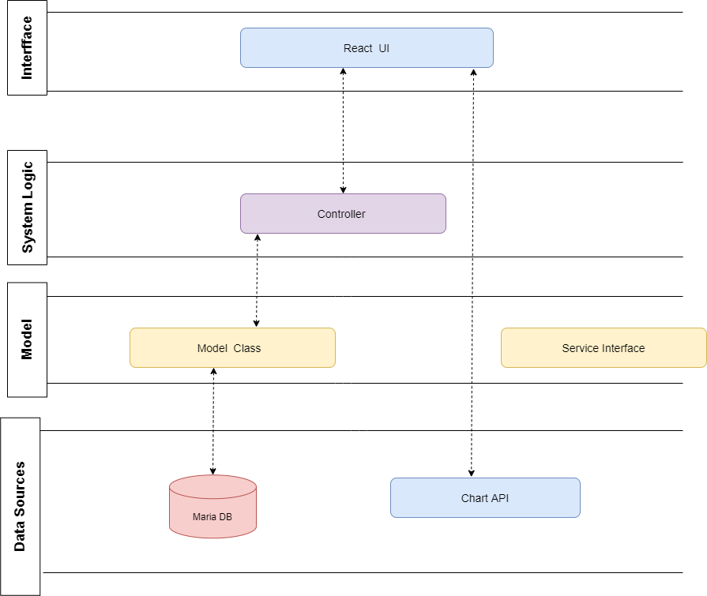

- Tools used
- Eclipse- is an IDE written for the development and debugging of mainly Java code.
- Spring boot-Tool I used to develop microservices with spring Framework.
- REST-This is an architectural framework I used to design and develop the services.
- Java-
- Postman: I used this to test the endpoints and document the API
- MSQL: For creating the database to store the expense details.

- User interface
The user Interface is built using React and has calls to the Controller service. It enables the user to input, view and manipulate i.e., add, edit, and delete expense.

- Images showing the interface
- General interface

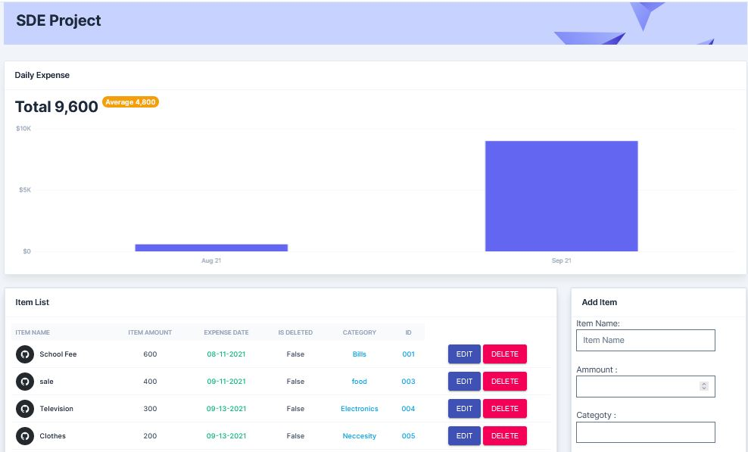

- Edit item details and add item
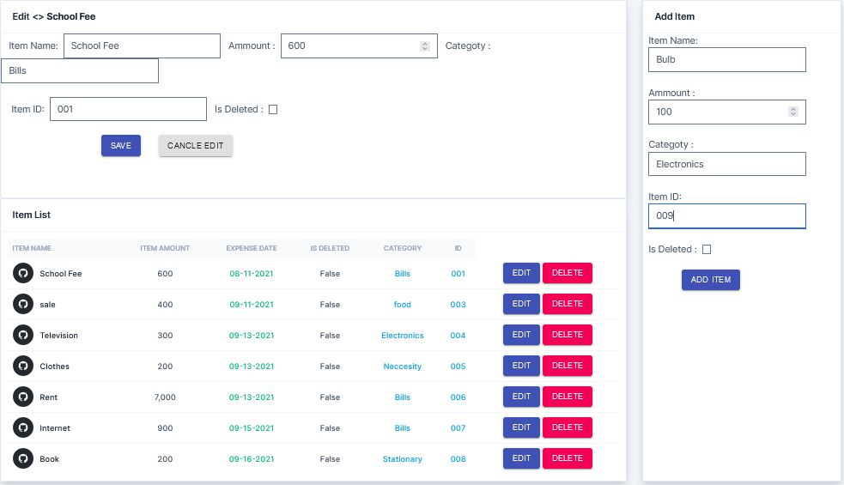
- Controller service
This service controls communication between the UI and the data source layer. It serves all HTTP requests coming directly from the user interface layer sends back the response to the caller. It is also responsible for all kinds of data manipulations, decision making and calculations. It is built in Java and REST.

- Client service
This service handles requests from the controller service and deals with fetching / retrieving of data. It is based on REST technology. Receiving of calls to fetch data is implemented basing on REST API.

- Server service
It is responsible for handling all data related requests i.e persistence and retrieval related tasks. It talks to the database adaptor. It also contains methods which are used in the persistence and retrieval of data at the database level.

- Model
This is used to create and manages entity classes, retrieves data from the database and helps you connect to the API.
- Database
I built the database using MariaDB. It consists of only one table with which stores the expense details i.e the expense id, category, expense date, status, item amount, item name,

- How it works
The user does not need to login, they just need to keep on inserting their daily details about the expenses made by providing the item/service name, id, category, without skipping a single day they have spent. This is recommended to enhance the usefulness of the service. They can create a new expense, edit an expense, delete, view expenses, and generate a summary report in form of a graph that displays the total amount spent and the average.

The user makes use of the various endpoints sending requests using the , GET, POST, DELETE operations.
Payload

